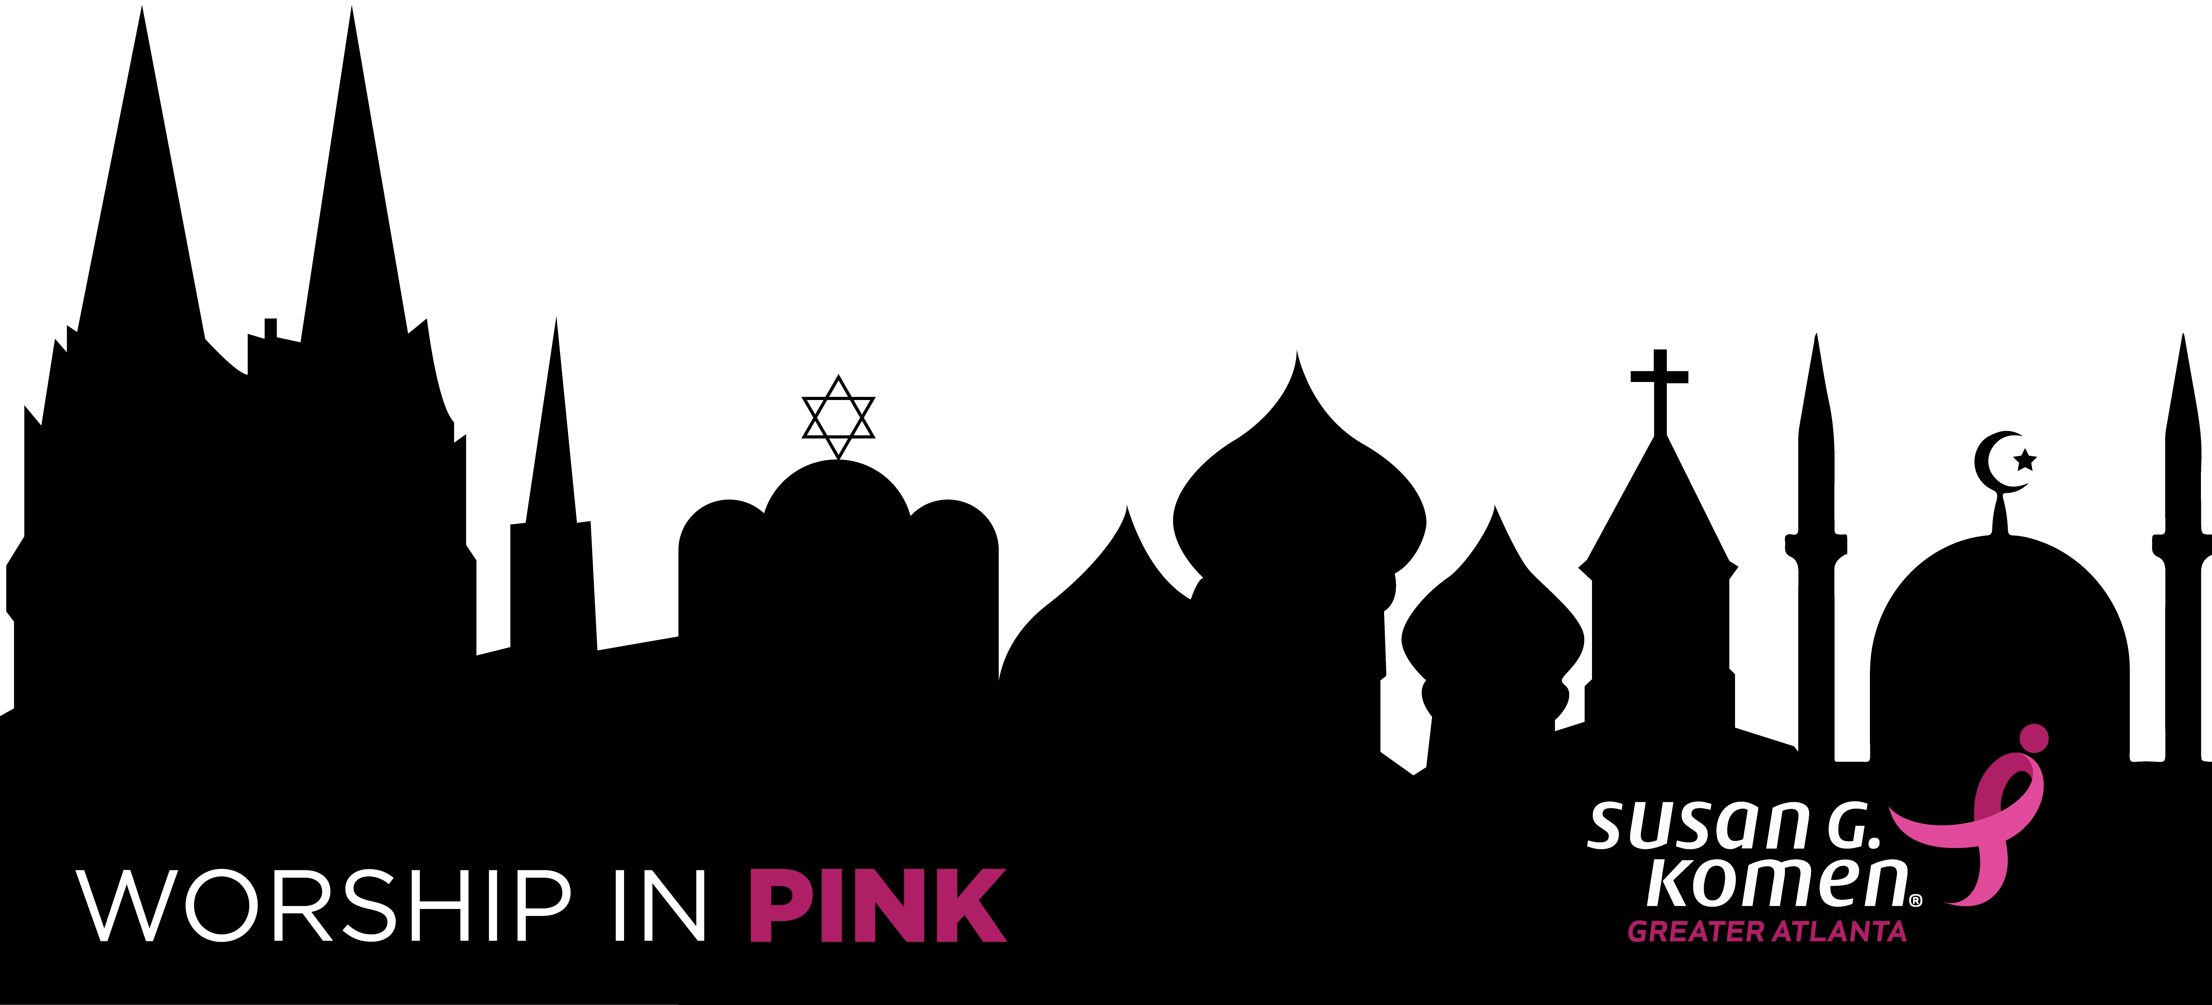

Faith-Based Organizations Social Media Toolkit

FACEBOOK | Account Name: Susan G. Komen Greater Atlanta  URL: www.facebook.com/SusanG.KomenGreaterAtlanta  - Tag Komen Atlanta’s account in your posts by typing “@SusanG.KomenGreaterAtlanta” so your members can click through to read more about Worship in Pink on our Facebook page  Promotion URL: komenatlanta.org/wip  Facebook Event: Worship in Pink – Susan G. Komen Greater Atlanta  - Event URL: facebook.com/events/378172566235286/  - Share with a post to your page via the event’s Share button  Sample Posts:  - Join us and Susan G. Komen Greater Atlanta as we Worship in Pink this October! Learn more here: komenatlanta.org/wip  - Susan G. Komen’s Worship in Pink program raises awareness of the importance of breast cancer early detection. Join us this October as we celebrate survivors and those who have fought against breast cancer! komenatlanta.org/wip  - Breast cancer can be overwhelming, but there is strength in faith. Join us as we Worship in Pink this October. Learn more about Susan G. Komen Greater Atlanta’s mission here: komenatlanta.org/wip  - Don’t forget that this Breast Cancer Awareness Month we will be joining Susan G. Komen Greater Atlanta to Worship in Pink as we celebrate the lives of breast cancer survivors and spread the lifesaving message of early detection! komenatlanta.org/wip  - Together, we can bring greater awareness to breast health and early detection. Join us as we Worship in Pink this October with Susan G. Komen Greater Atlanta! Learn more about the program here: komenatlanta.org/wip  - $140 is the cost to provide one mammogram - and the chance to help save a life! Support Susan G. Komen Greater Atlanta‘s Worship in Pink mission here and learn more about the program: komenatlanta.org/wip
INSTAGRAM | Account Name: @KomenAtlanta  URL: www.instagram.com/KomenAtlanta  Hashtags: #WorshipInPinkATL #KomenAtlanta #ATLisMoreThanPink #NBCAM  Promotion URL: komenatlanta.org/wip  - Update the link in your account bio to this URL for easy access to more information  Sample Posts:  - Join us and @komenatlanta as we Worship in Pink this October! Learn more here: komenatlanta.org/wip #WorshipInPinkATL #KomenAtlanta #ATLisMoreThanPink #NBCAM  - @komenatlanta‘s Worship in Pink program raises awareness of the importance of breast cancer early detection. Join us this October as we celebrate survivors and those who have fought against breast cancer! komenatlanta.org/wip #WorshipInPinkATL #KomenAtlanta #ATLisMoreThanPink #NBCAM  - Breast cancer can be overwhelming, but there is strength in faith. Join us as we Worship in Pink this October. Learn more about @komenatlanta‘s mission here: komenatlanta.org/wip #WorshipInPinkATL #KomenAtlanta #ATLisMoreThanPink #NBCAM  - Don’t forget that this Breast Cancer Awareness Month we will be joining @komenatlanta to Worship in Pink as we celebrate the lives of breast cancer survivors and spread the lifesaving message of early detection! komenatlanta.org/wip #WorshipInPinkATL #KomenAtlanta #ATLisMoreThanPink #NBCAM  - Together, we can bring greater awareness to breast health and early detection. Join us as we Worship in Pink this October with @komenatlanta! Learn more about the program here: komenatlanta.org/wip #WorshipInPinkATL #KomenAtlanta #ATLisMoreThanPink #NBCAM  - $140 is the cost to provide one mammogram - and the chance to help save a life! Support @komenatlanta‘s Worship in Pink mission here and learn more about the program: komenatlanta.org/wip #WorshipInPinkATL #KomenAtlanta #ATLisMoreThanPink #NBCAM
TWITTER | Account Name: @KomenAtlanta  URL: www.twitter.com/komenatlanta  Hashtags: #WorshipInPinkATL #KomenAtlanta #ATLisMoreThanPink #NBCAM  Promotion URL: komenatlanta.org/wip  Sample Tweets:  - Join us and @komenatlanta as we Worship in Pink this October! Learn more here: komenatlanta.org/wip #WorshipInPinkATL  - @komenatlanta‘s Worship in Pink program raises awareness of the importance of breast cancer early detection. Join us this October as we celebrate survivors and those who have fought against breast cancer! komenatlanta.org/wip #WorshipInPinkATL  - Breast cancer can be overwhelming, but there is strength in faith. Join us as we Worship in Pink this October. Learn more about @komenatlanta‘s mission here: komenatlanta.org/wip #WorshipInPinkATL  - Don’t forget that this Breast Cancer Awareness Month we will be joining @komenatlanta to Worship in Pink as we celebrate the lives of breast cancer survivors and spread the lifesaving message of early detection! komenatlanta.org/wip #WorshipInPinkATL #NBCAM  - Together, we can bring greater awareness to breast health and early detection. Join us as we Worship in Pink this October with @komenatlanta! Learn more about the program here: komenatlanta.org/wip #WorshipInPinkATL  - $140 is the cost to provide one mammogram - and the chance to help save a life! Support @komenatlanta‘s Worship In Pink mission here and learn more about the program: komenatlanta.org/wip #WorshipInPinkATL

SCROLL DOWN FOR IMAGES

IMAGES
Right click and “Save as Picture”

